COUNCIL ASSESSMENT REPORT

|  |  |  |
| --- | --- | --- |
| **Panel Reference** | PPSSTH-130 | |
| **DA Number** | RA21/1001 | |
| **LGA** | Shoalhaven City Council | |
| **Proposed Development** | Proposed 47 Unit Industrial Development, Ancillary Café, access driveways, signage and landscaping | |
| **Street Address** | 17 Norfolk Avenue, SOUTH NOWRA - Lot 116 DP 1122371 | |
| **Applicant/Owner** | Shoalhaven City Council | |
| **Date of DA lodgement** | 17 November 2021 | |
| **Total number of Submissions**  **Number of Unique Objections** | One (1) | |
| **Recommendation** | Approval | |
| **Regional Development Criteria (Schedule 6 of SEPP (Planning Systems) 2021** | Schedule 6 Clause 3 - Council related development over $5 million  CIV = $8,334,817 | |
| **List of all relevant s4.15(1)(a) matters** | * State Environmental Planning Policy (Biodiversity and Conservation) 2021 * State Environmental Planning Policy (Industry and Employment) 2021 * State Environmental Planning Policy (Resilience and Hazards) 2021 * State Environmental Planning Policy (Transport and Infrastructure) 2021 * Shoalhaven Local Environmental Plan 2014 * Shoalhaven Development Control Plan 2014 | |
| **List all documents submitted with this report for the Panel’s consideration** | Attachment 1 – Section 4.15 Assessment Report  Attachment 2 – Recommended conditions of consent.  Attachment 3 – Assessment of Shoalhaven Development Control Plan 2014  Attachment 3 – Architectural Plans  Attachment 4 – Applicant-provided reports accompanying architectural plans | |
| **Clause 4.6 requests** | N/A | |
| **Summary of key submissions** | Council needs to carefully consider the intensification of the industrial area, particularly in relation to impacts of increased traffic, the interaction of light and heavy vehicles, and vehicle safety entering/exiting driveways. | |
| **Report prepared by** | **Tyson Ek-Moller (Creative Planning Solutions), Consultant Planner** | |
| **Report date** | 17 August 2022 | |
| **Summary of s4.15 matters**  Have all recommendations in relation to relevant s4.15 matters been summarised in the Executive Summary of the assessment report? | | **Yes** | |
| **Legislative clauses requiring consent authority satisfaction**  Have relevant clauses in all applicable environmental planning instruments where the consent authority must be satisfied about a particular matter been listed, and relevant recommendations summarized, in the Executive Summary of the assessment report?  *e.g. Clause 7 of SEPP 55 - Remediation of Land, Clause 4.6(4) of the relevant LEP* | | **Yes** | |
| **Clause 4.6 Exceptions to development standards**  If a written request for a contravention to a development standard (clause 4.6 of the LEP) has been received, has it been attached to the assessment report? | | **Not applicable** | |
| **Special Infrastructure Contributions**  Does the DA require Special Infrastructure Contributions conditions (S7.24)?  *Note: Certain DAs in the Western Sydney Growth Areas Special Contributions Area may require specific Special Infrastructure Contributions (SIC) conditions* | | **Not applicable** | |
| **Conditions**  Have draft conditions been provided to the applicant for comment?  *Note: in order to reduce delays in determinations, the Panel prefer that draft conditions, notwithstanding Council’s recommendation, be provided to the applicant to enable any comments to be considered as part of the assessment report* | | **Yes** | |

Executive Summary

The subject site is located on the northwest side of Norfolk Avenue and forms part of the Flinders Industrial area. The land is identified by title as Lot 116 in Deposited Plan 1122371, and has a street address of 17 Norfolk Avenue, South Nowra.

The site comprises of an irregularly-shaped allotment with an area of 13,500m2. The site does not contain any structures. The site is cleared of vegetation; historically, the site was heavily vegetated, with both the site and land to the rear/northwest being cleared in 2021. The entire site is bush fire prone land and is mapped as being affected by class 5 acid sulphate soils.

Sites within the Flinders Industrial Estate to the north, south and east of the subject site contain a range of industrial buildings and associated land uses; surrounding sites to the northwest, west and southwest are undeveloped and cleared, with sites further to the west and southwest being heavily vegetated.

Shoalhaven City Council (Council) is in receipt of Development Application no. RA21/1001, which was lodged on 17 November 2021. The DA proposes the construction of 47 industrial units, an ancillary café, civil works (including stormwater works, access driveways and parking), signage and landscaping. Aside from the ancillary café, the uses of the individual industrial units are not proposed and will be subject to separate consents.

The land is zoned IN1 General Industrial under the *Shoalhaven Local Environmental Plan 2014* (SLEP 2014). Development for the purpose of a “general industry” (as defined by SLEP 2014) is permissible with consent in the IN1 zone. A *café* is however prohibited within the zone, and it is not agreed that the proposed *café* is an ancillary use. Conditions are recommended that will require changes to the design and operation of the proposed café so that this part of the development operates as a “take away food and drink premises”, which is a permissible land use in the IN1 zone.

Pursuant to cl. 3(b) of *State Environmental Planning Policy (Planning Systems) 2021*, the proposal constitutes regionally-significant development, as Council is the owner of the site and the Capital Investment Value (CIV) of the proposed development is $8,334,817. As such, the Southern Regional Planning Panel (SRPP) is the consent authority for the DA.

The DA has been assessed against the following relevant environmental planning instruments and demonstrates compliance with the relevant provisions is achievable, subject to the recommended conditions of consent:

* *Shoalhaven Local Environmental Plan 2014*,
* *State Environmental Planning Policy (Biodiversity and Conservation) 2021*,
* *State Environmental Planning Policy (Industry and Employment) 2021*,
* *State Environmental Planning Policy (Resilience and Hazards) 2021*, and
* *State Environmental Planning Policy (Transport and Infrastructure) 2021*

The application has been assessed against the following chapters of the Shoalhaven Development Control Plan 2014 (SDCP 2014):

* G1: Site Analysis, Sustainable Design and Building Materials in Rural and Coastal Areas
* G2: Sustainable Stormwater Management and Erosion/Sediment Control
* G3: Landscaping Design Guidelines
* G7: Waste Minimisation and Management Controls
* G20: Industrial Development
* G21: Car Parking and Traffic
* G22 Advertising Signs and Structures
* G26 Acid Sulfate Soils and Geotechnical (Site Stability) Guidelines

The development demonstrates satisfactory compliance with each chapter of SDCP 2014. The planning assessment identified some non-compliances with Chapters G1, G20, G21 and G22. Such noncompliances relate to the lack of a site analysis plan, inadequate solar access information, a front setback variation, the length of unbroken walls along the side elevations of the building, inadequate pedestrian facilities, inadequate manoeuvring space for large vehicles, and the size of free-standing signage at the front of the site. This planning assessment has found that most non-compliances are either justifiable and/or can be addressed by conditions in the event of approval.

The proposed layout of the development is however inadequate to permit the access and internal circulation of articulated vehicles, therefore a condition is recommended that will prohibit access to the site by articulated vehicles.

The DA is also reliant upon the creation of easements on a Council-owned site that adjoins the rear boundary to both:

* Facilitate the discharge of stormwater from the southern part of the site to the public drainage system, and
* To facilitate the creation of an Asset Protection Zone (APZ) that is required to protect the rear of the site in the event of a bushfire within vegetated areas to the west.

The creation of easements to benefit the subject site are supported by Council’s technical officers, however the easements are to be registered prior to the activation of any consent issued for the DA. The creation of the drainage easement(s) is therefore subject to deferred-commencement conditions in the event that the DA is approved.

The DA was notified in accordance with the Shoalhaven Council Community Participation Plan 2019 from 8 December 2011 until 7 January 2022. One (1) submission was received by Council during the notification period.

Subject to conditions, the site is suitable for the proposed development in its present form.

With regard to the above matters, the proposal is in the public interest.

It is recommended the application be approved in accordance with the reasons for approval attached to this report.

# Detailed Proposal

The Cof a Development Application (DA) for the construction of an industrial development, that includes 47 industrial units, an ancillary café, civil works including onsite stormwater infrastructure and driveways, signage and landscaping.

As the site is a vacant allotment, demolition works are not proposed. Subdivision of the proposed development is not proposed.

The café and industrial units are to be contained within four (4) main buildings with varying numbers of industrial units. Two of the buildings are proposed to be built along the side boundaries and will extend from the front setback line to the rear boundary. The other two buildings are to be located at the rear of the site (i.e. at the site’s widest point), between the aforementioned buildings that are to be built to the side boundaries; one of these buildings will be built to the rear boundary, with the other to be set back seven metres from the rear boundary. The four buildings are to be internally separated by internal driveways and parking areas.

The development is also proposed to include facilities for vehicular access and internal manoeuvring, which will utilise a single driveway layback and crossover and internal driveway throughout the site. 115 onsite car parking spaces (including two (2) accessible car parking spaces) are proposed. Onsite drainage includes onsite pits, pipes and three Onsite Stormwater Detention (OSD) systems, which will connect to two drainage easements (one of which is to be created) adjoining the rear boundary. Landscaping works are proposed, as is signage which includes:

* A double-sided freestanding pylon sign, which is proposed to be located on the northern side of the proposed driveway crossover,
* Wall signage on the front and southern-side elevations of the café,
* Wall signage areas above each of the loading docks for each tenancy, and
* Internal wayfinding signage.

Aside from the café, separate consents are to be attained for the uses of the industrial units.

The proposed hours of operation for the café are 7:00am to 5:00pm, Monday to Friday.

Extracts of the site plan, landscape plan, elevations, sections, and 3D perspectives of the development are provided in **Figures 1 to 6**.

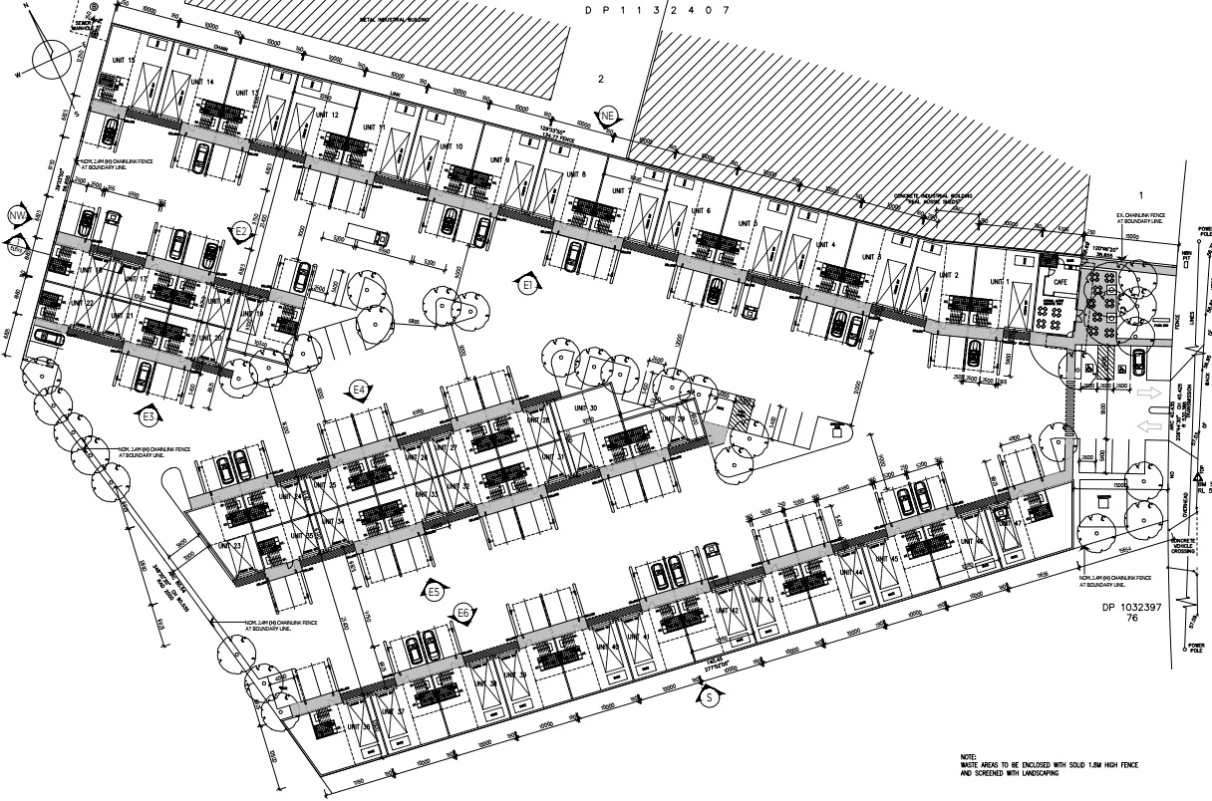Figure 1 – Site/ground floor plan of the proposed development (Note: the plan extract is from the latest revision, dated 21 July 2022).

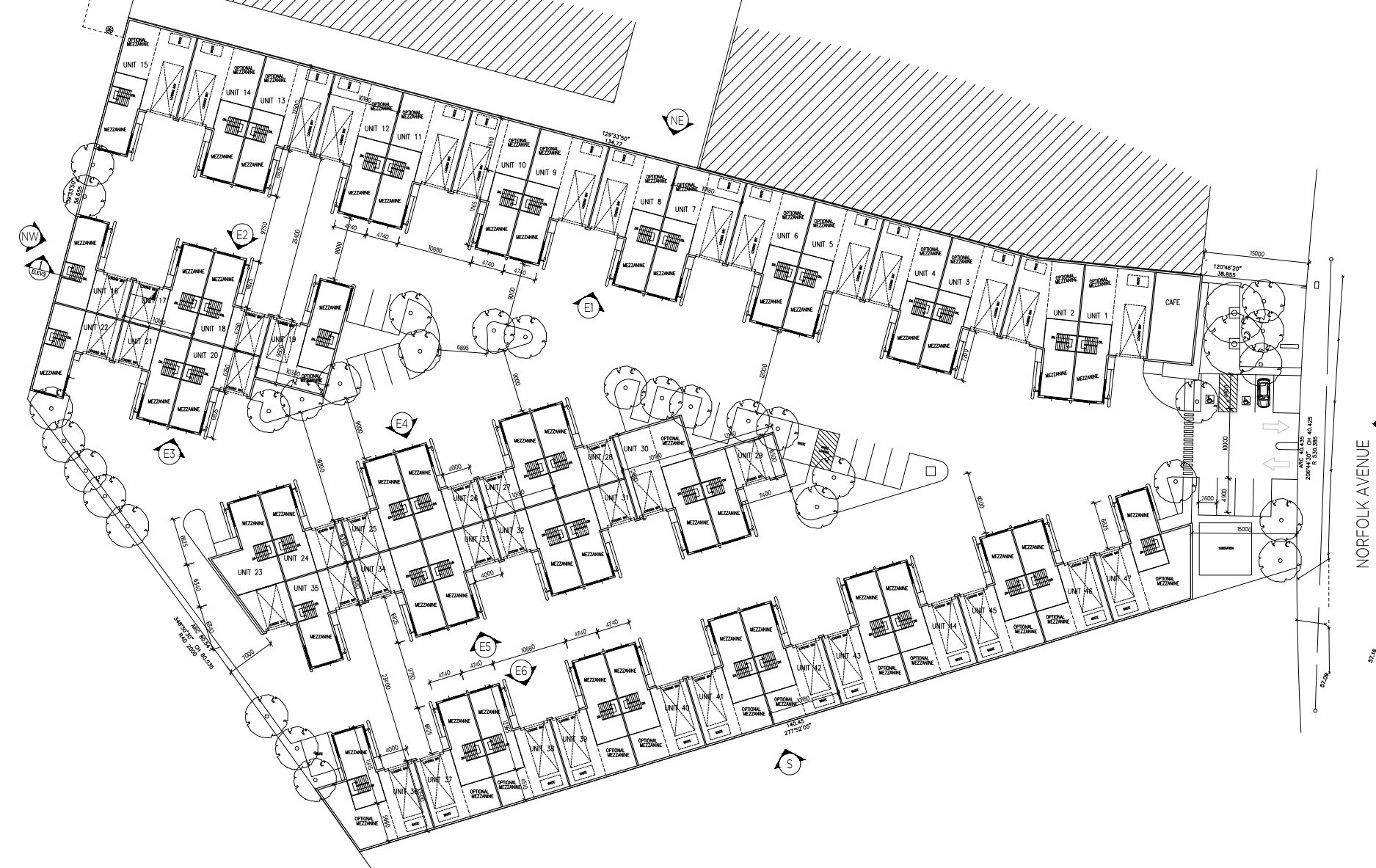

Figure 2 – First floor plan of the proposed development (Note: the plan extract is from the latest revision, dated 21 July 2022).

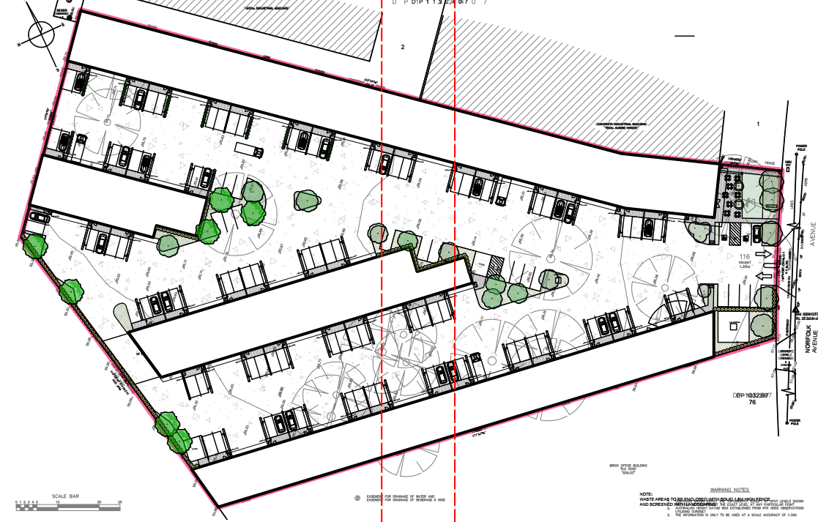

Figure 3 - Landscape plan of the proposed development (Note: the plan extract is from the latest revision, dated 29 July 2022).

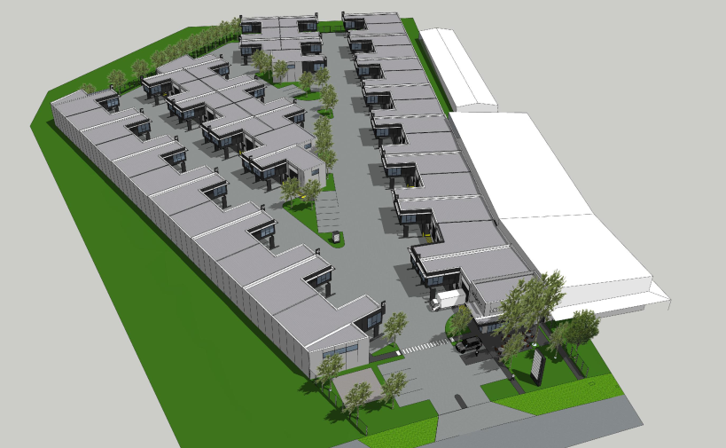

Figure 4 – A 3D visual representation of the proposed development, as viewed from the east of the site.

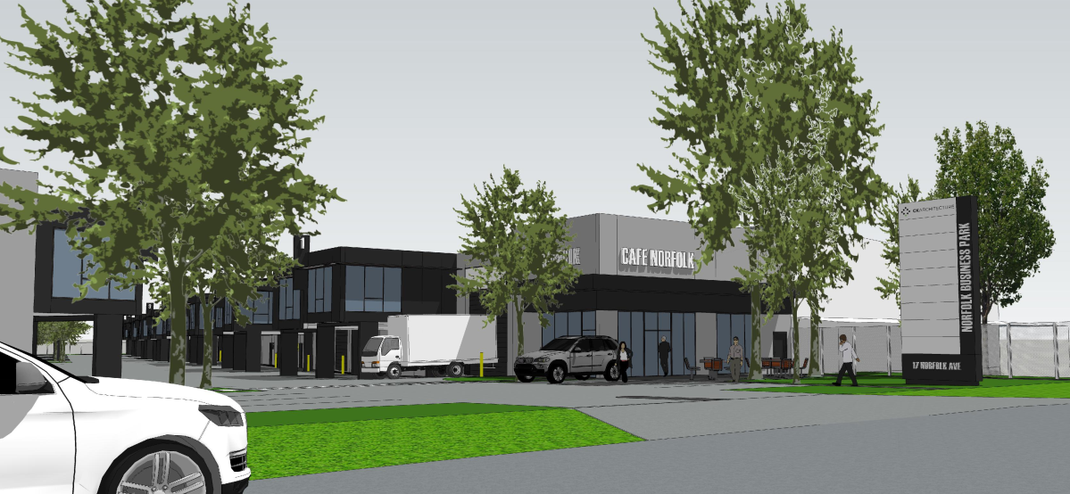

Figure 5 – A 3D visual representation of the proposed development from the east within Norfolk Avenue.

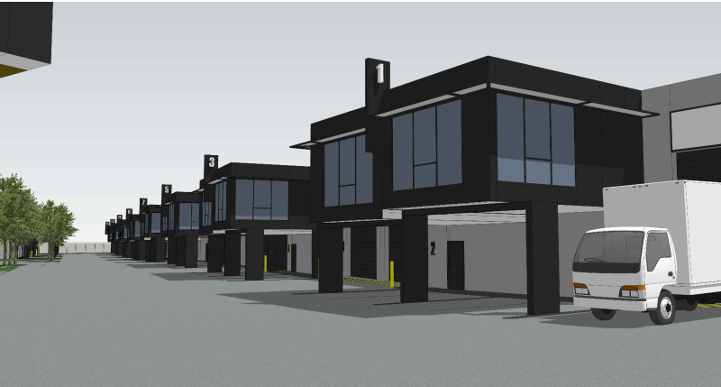

Figure 6 – A 3D visual representation of the proposed development from within the site between the café and Unit 47.

# 2. Subject Site and Surrounds

The street address of the subject site is 17 Norfolk Avenue, South Nowra NSW, 2571. It comprises of one allotment identified by title as Lot 116 within Deposited Plan 1122371.

The site is located on the northwest side of Norfolk Avenue. The front boundary adjoins the Norfolk Avenue road reserve, and both side boundaries adjoin developed industrial sites. The rear boundary adjoins undeveloped allotments. The site has an area of 13,500m2 (1.35 hectares) with a gentle front-to-rear slope varying between 1.3 and 2.2 metres. The site is irregularly shaped; progressively widening from a curved 40.435 metre front boundary to a split northwest/southwest-oriented rear boundary with a combined length of 137.19 metres.

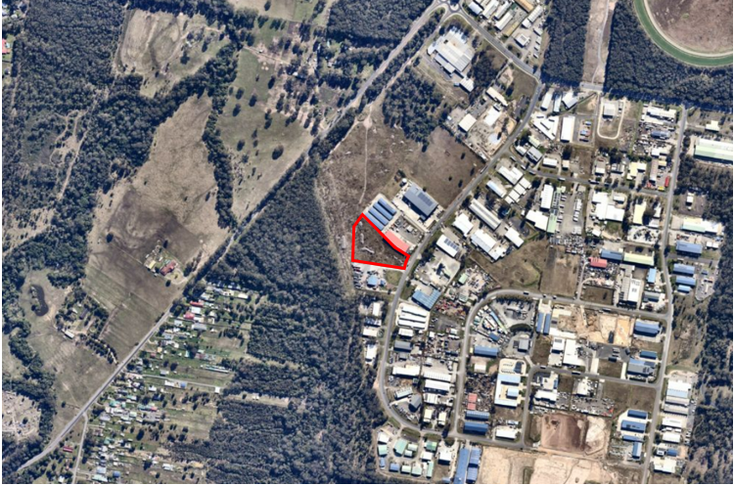

Figure 7 – Aerial image of the subject site (outlined by the red border) in the local context (Source: Nearmap, 30 July 2022, modified by CPS 10 August 2022)

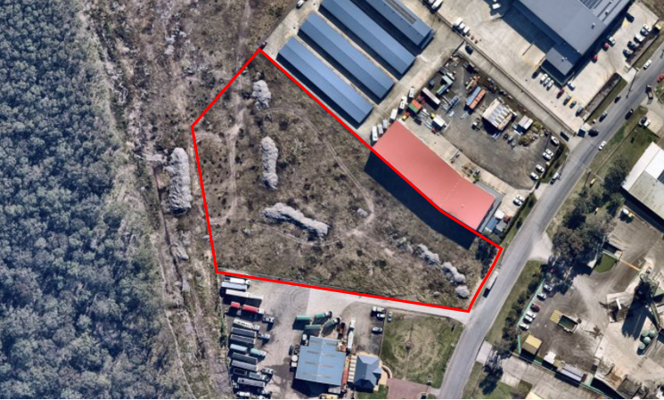

Figure 8 – Aerial image of the subject site (outlined by the red border) in the local context (Source: Nearmap, 30 July 2022, modified by CPS 10 August 2022)

The subject site and all adjoining sites are within the IN1 General Industrial zone under the *Shoalhaven Local Environmental Plan 2014*; the nearest zone boundary is a C3 Environmental Management zone, approximately 30 metres west/southwest of the subject site. The site is mapped as being bushfire prone and affected by class 5 acid sulphate soils, however the site is not identified as being subject to any other environmental hazards or affectations. The site does not contain a heritage item, is not within a Heritage Conservation Area and is not located in close proximity to a heritage item.

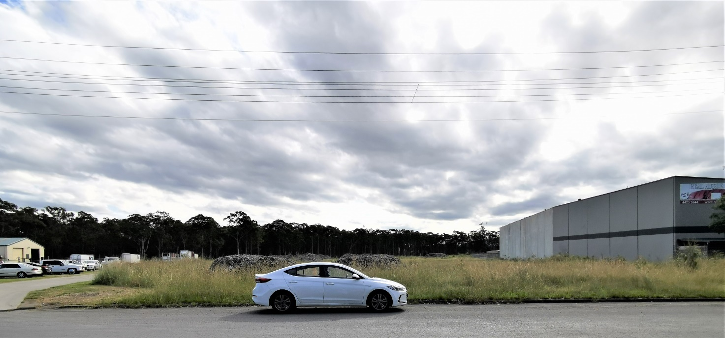

Figure 9 – A photo of the subject site, taken from the southeast (i.e. opposite) side of Norfolk Avenue. (Source: CPS, 21 April 2022)

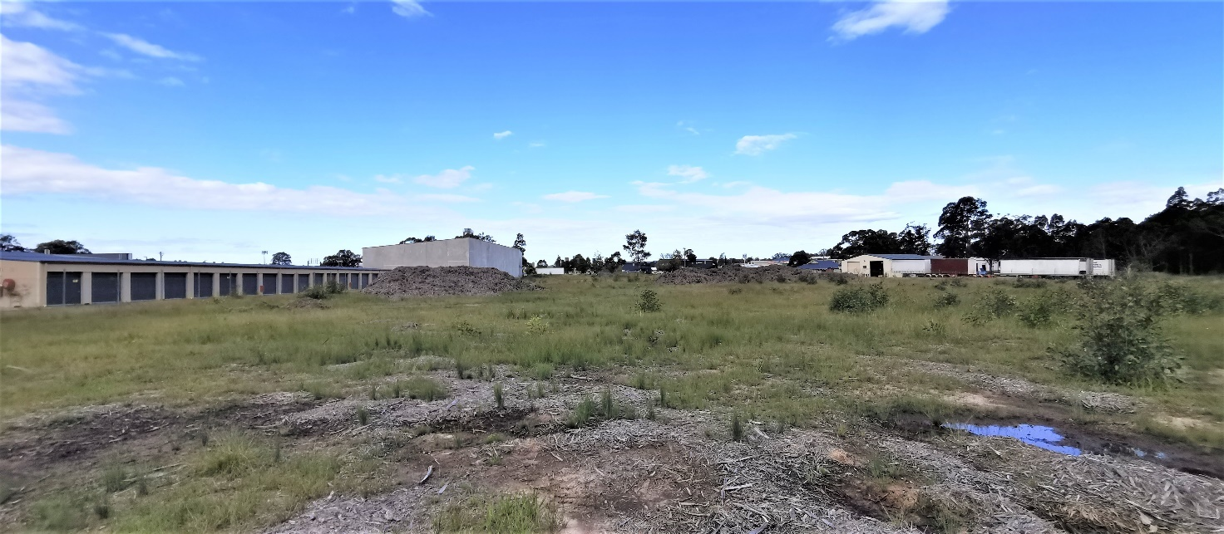

Figure 10 – A photo of the subject site, as viewed from the northwest side of the rear boundary (Source: CPS, 21 April 2022)

The subject site is currently undeveloped, and vehicular access is not currently provided to the site. There are also no trees on the subject site or within the road reserve to the front of the site. The western side of the Norfolk Avenue road reserve adjacent to the subject site’s road frontage contains overhead 11kV power lines.

The subject site is located on the western side of the Flinders Industrial estate, which is located to the southwest of the Nowra town centre. Development on surrounding sites within this precinct include a variety of industrial buildings and associated activities.

The sites adjoining the northeast side boundary include 13 and 15 Norfolk Avenue; development on these sites include large warehouse and shed type structures. The site adjoining the southern boundary is 19 Norfolk Avenue; the forward part of this site contains a dwelling-type structure that is being used as an office, the centre of the site contains a large warehouse-type structure while the rear area includes a large at-grade area that is being used for heavy vehicle storage. The site on the eastern (i.e. opposite) side of Norfolk Avenue includes a variety of structures that form part of a concrete batching plant.

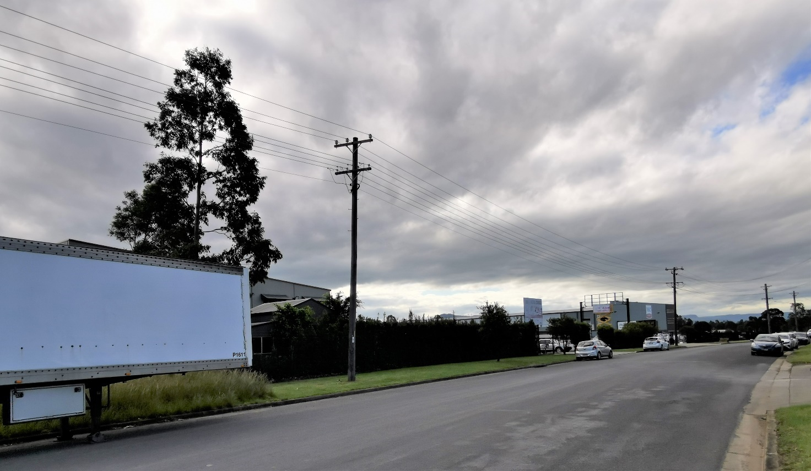

Figure 11 – A photo taken from the southeast (i.e. opposite) side of Norfolk Avenue looking north towards 15 and 11 Norfolk Avenue. (Source: CPS, 21 April 2022)

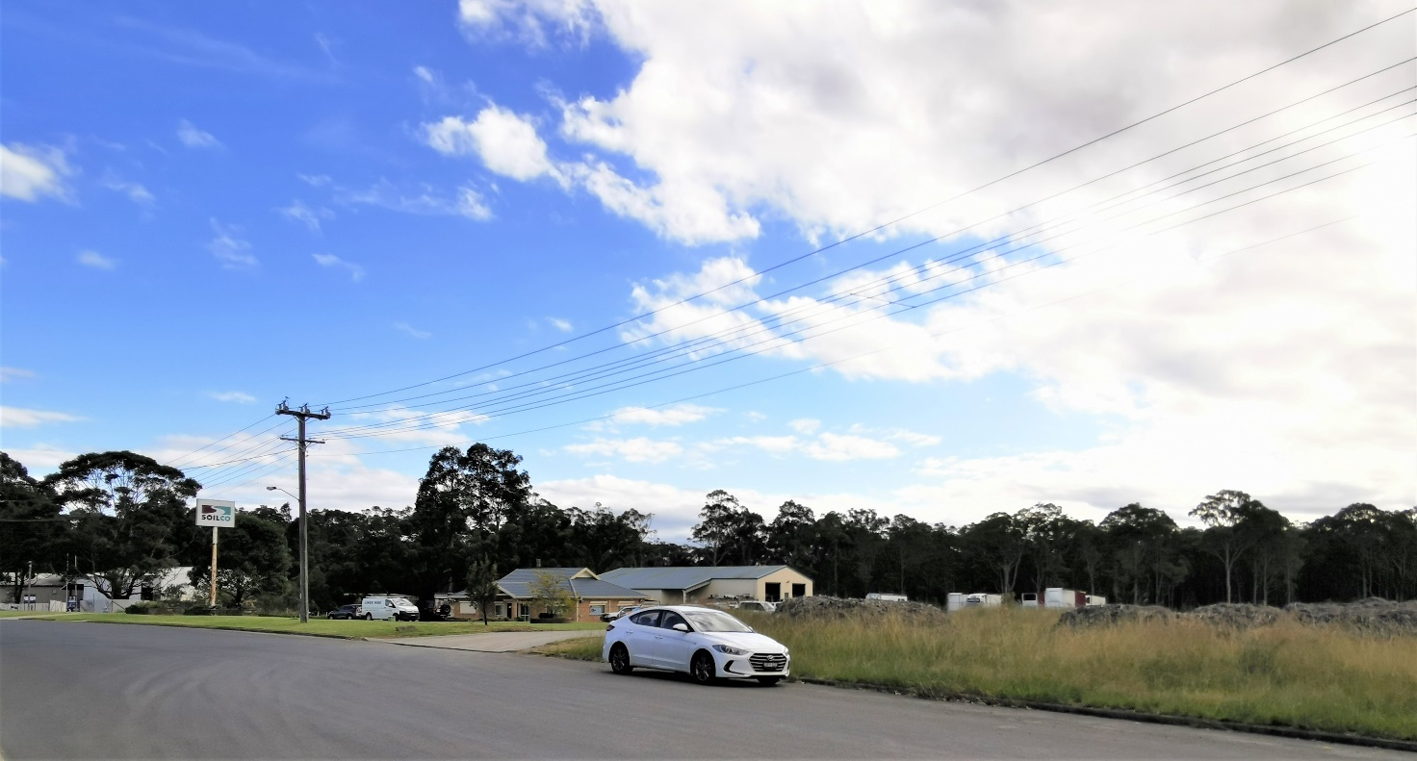

Figure 12 – A photo taken from the southeast (i.e. opposite) side of Norfolk Avenue looking southwest towards 19 and 21 Norfolk Avenue. (Source: CPS, 21 April 2022)

Sites within the wider area to the north, south and east of the site contain a wide range of industrial structures and associated uses. Sites to the west of the site are undeveloped; sites adjoining the rear boundary are both undeveloped and cleared of vegetation, while C3-zoned sites further to the west are heavily vegetated. Sites beyond those C3-zoned areas further to the southwest (i.e. approximately 230 metres from the site) contain large lot residential development.

Deposited Plan and 88B Instrument

There are no easements or restrictions on the subject site that would limit development of the site as proposed. The DA does however propose to connect the proposed stormwater system to a drainage easement on an adjoining allotment (Lot 117 in Deposited Plan 1122371); a second drainage easement is to also be created within an adjoining site (Lot 40 in Deposited Plan 802671) to enable drainage from southern parts of the site. The NSW Rural Fire Service (RFS) also recommends a condition that will impose a restriction on the use of the subject site and areas of adjoining land projecting 22 metres out from the subject site that will require such areas to be managed as an Inner Protection Area (IPA).

# 3. Background

Post-Lodgement

3 December 2021: A Request for Additional Information (RFI) was sent to the applicant, seeking additional and amended information relating to cost of works, clarification of café layout, changes to parking, information regarding heavy vehicle manoeuvring, a Water Cycle Management Plan and clarification on unit sizes.

10 December 2021: An RFI was sent to the applicant seeking additional and amended information relating to waste management (including ongoing storage and collection of waste).

10 March 2022: Amended and additional information received.

4 May 2022: Further additional information received.

21 April 2022: A site inspection was undertaken by the consultant planner.

1 July 2022: A response to the requested information received from the applicant.

7 July 2022: An RFI was sent to the applicant, seeking additional and amended information relating to matters including site layout, revised plans, bushfire related matters, setbacks, landscaped areas, boundary fences, revised colour schedule and information on the cost of works, clarification of the café layout, changes to parking, and general information to assist with the planning assessment.

29 July 2022: Additional information received.

Site History and Previous Approvals

14 August 2003: Subdivision Consent no. SF9327 approved for a six (6) lot industrial subdivision.

Council’s online Development Application tracker does not have a record of any application for development upon the site since the approval of the subdivision that created the subject site.

# 4. Consultation and Referrals

|  |  |  |  |
| --- | --- | --- | --- |
| **Internal Referrals** | | | |
| Referral | Required | Recommendation | Comment |
| Building Surveyor |  | Approval, subject to conditions to address the following matters:   * Stormwater * Fire safety * Long service levy * Plumbing and drainage * Retaining walls | Council has not been nominated for the Construction Certificate or as the certifying authority.  In this regard, no National Construction Code (NCC) assessment has been completed for the proposal. The proposal may be subject to performance base solutions provisions of the NCC. |
| Development Engineer |  | Deferred commencement approval.  Conditions are recommended to address the following matters prior to the activation of consent:   * Drainage * Easement registration   Conditions are recommended to address the following matters following activation of the consent:   * Stormwater and drainage * Waste management * Vehicle access and onsite manoeuvring * Waste servicing | Conditions have been suggested below to deal with outstanding matters. The DAO may need to consider whether it is appropriate to condition establishment of an easement or if consent is required prior to determination. |
| Environmental Health |  | Approval, subject to conditions regarding registration and regulation of food premises. | Environmental Health have reviewed this proposed development which includes an ancillary café and have no objections to this proposal. The inclusion of Master Document conditions for Food Business Regulations and Food Business Notification will suffice. |
| City Services |  | No objection, subject to conditions (imposed by both City Services and Development Engineering) | The City Services comments have been co-ordinated with the development engineering referral. |
| Property |  | Conditions are recommended for compliance with the NCC, fire safety and partial building upgrades to the existing building | An easement for both the stormwater drainage and necessary APZ could both be dealt with as a deferred commencement condition, requiring evidence of registration of such easements over that neighbouring land, prior to operational consent. **Note:** Conditionsrecommended by the NSW RFS do not require title restrictions relating to APZs to be undertaken as a deferred-consent requirement. |
| Shoalhaven Water |  | No objection to proposal, subject to a condition requiring that a Certificate of Compliance be submitted in order to obtain a Water Development Notice. | A Certificate of Compliance is to be lodged prior to the issue of a Construction Certificate. |

|  |  |  |  |
| --- | --- | --- | --- |
| **External Referrals** | | | |
| Agency | Required | Recommendation | Comment |
| Energy supply authority (Endeavour Energy) |  | A referral response was received on 20 December 2021 that indicated the proposal will require an extension and/or augmentation of the existing local network, though the extent of any works will not be determined until a final load assessment (subject to conditions) is completed. No objection was raised to the proposal, subject to conditions and advice in the event of approval. | No further action required. |
| NSW Rural Fire Service (RFS) |  | A final referral response was received by Council on 16 August 2022. No objection was raised to the proposal, subject to conditions and advice in the event of approval. The conditions require the entirety of the site being managed as an Inner Protection Area (IPA), and restrictions of land use on adjoining sites to the northwest and southwest that will require areas up to 22 metres from the subject site being managed as an IPA. | No further action required. |

# 5. Other Approvals

The proposed development is not integrated nor development under s.4.46 of the *Environmental Planning and Assessment Act 1979.*

# 6. Statutory Considerations

This report assesses the proposed development against relevant State, Regional and Local Environmental Planning Instruments and policies in accordance with Section 4.15 (1) of the *Environmental Planning and Assessment Act 1979* (EP&A Act). The following planning instruments and controls apply to the proposed development:

| Instrument | Relevant | Instrument | Relevant |
| --- | --- | --- | --- |
| Shoalhaven LEP 2014 |  | State Environmental Planning Policy (Industry and Employment) 2021 |  |
| State Environmental Planning Policy SEPP (Planning Systems) 2021 |  | State Environmental Planning Policy (Resilience and Hazards) 2021 |  |
| State Environmental Planning Policy (Biodiversity and Conservation) 2021 |  | State Environmental Planning Policy (Transport and Infrastructure) 2021 |  |

Additional information on the proposal’s compliance with the above planning instruments is detailed below in Section 7 (Statement of Compliance/Assessment) of this report.

# 7. Statement of Compliance/Assessment

The following provides an assessment of the submitted application against the matters for consideration under Section 4.15 of the EP&A Act.

# (a) Any planning instrument, draft instrument, DCP and regulations that apply to the land

Environmental Planning and Assessment Act 1979

## Environmental planning instrument

SEPP (Planning Systems) 2021

Pursuant to cl. 3(b) of this SEPP, the proposal constitutes regionally-significant development, as the CIV of the proposal is $8,334,817 and Council is the owner of the site. As such, the SRPP is the consent authority for the DA.

SEPP (Biodiversity and Conservation) 2021

Pursuant to clauses 3.3 and 3.5, Chapter 3 of this SEPP applies to the site. With regard to cl. 3.6, as demonstrated by ***Figure 8***, the site has already been cleared of all vegetation; neither of the adjoining sites contain any significant trees and vegetation, and there is a significant (i.e. minimum 30 metre) cleared buffer area between the rear boundary of the site and any significant trees. Pursuant to cl. 3.6(3) of this SEPP, Council can therefore be satisfied the land is not a potential koala habitat, and is not prevented from granting consent to the DA.

Chapter 4 (Koala habitat protection 2021) applies to the site. Pursuant to cl. 4.9(2), prior to granting consent Council must consider whether the development is likely to have any impact on koalas or koala habitat. As indicated above and as demonstrated by ***Figure 8***, the site does not constitute likely koala habitat; further, a lack of vegetation and the form of development on surrounding sites to the north, east and south of the site is such that it is unlikely that koalas will traverse the site in order to obtain access to habitats or food sources. It is therefore considered that the development is likely to have low or no impact on koalas or koala habitat, and consent may be granted to the proposed development.

SEPP (Industry and Employment) 2021

The provisions of Chapter 3 (Advertising and signage) apply given the proposal includes signage that is visible from a public place (i.e. the Norfolk Avenue road reserve) that is not exempt development. Pursuant to cl. 3.6(b) this SEPP, the consent authority must not grant consent to signage unless it is satisfied that the assessment criteria of Schedule 5 (Assessment criteria) of this SEPP is met. An assessment of Schedule 5 is contained within the following table.

|  |  |
| --- | --- |
| **Schedule 5 Assessment criteria** | **Comment** |
| **1 Character of the area** | |
| Is the proposal compatible with the existing or desired future character of the area or locality in which it is proposed to be located?  Is the proposal consistent with a particular theme for outdoor advertising in the area or locality? | The design, placement and location of the signage is consistent with the Flinders Industrial precinct, noting that development on surrounding sites contains a variety of signage including pylon freestanding signs, free-standing signage structures and on-building signage. |
| **2 Special areas** | |
| Does the proposal detract from the amenity or visual quality of any environmentally sensitive areas, heritage areas, natural or other conservation areas, open space areas, waterways, rural landscapes or residential areas? | The proposed signage will not detract from the amenity or visual quality of the locality, noting that it is located within an industrial precinct. There are no heritage items, areas of environmental sensitivity or open areas that will be adversely affected by the signage. |
| **3 Views and vistas** | |
| Does the proposal obscure or compromise important views?  Does the proposal dominate the skyline and reduce the quality of vistas?  Does the proposal respect the viewing rights of other advertisers? | The proposed signs will not obscure important views and surrounding signage. The heights of all proposed signs will be less than the proposed buildings to which the signs relate, and therefore will not dominate the skyline. |
| **4 Streetscape, setting or landscape** | |
| Is the scale, proportion and form of the proposal appropriate for the streetscape, setting or landscape?  Does the proposal contribute to the visual interest of the streetscape, setting or landscape?  Does the proposal reduce clutter by rationalising and simplifying existing advertising?  Does the proposal screen unsightliness?  Does the proposal protrude above buildings, structures or tree canopies in the area or locality?  Does the proposal require ongoing vegetation management? | The scale, form and proportions of the signage are consistent with the streetscape setting within Norfolk Avenue. Advertising located at the front of the site will be rationalised, noting that signs within this part of the site will both advertise and identify the café and other business on the site.  All proposed signs will be located below the maximum heights of the proposed buildings with which the signs are to be associated, therefore they will not protrude above buildings, or structures.  The submitted information indicates that ongoing landscape maintenance will be unrelated to the proposed signage. |
| **5 Site and building** | |
| Is the proposal compatible with the scale, proportion and other characteristics of the site or building, or both, on which the proposed signage is to be located?  Does the proposal respect important features of the site or building, or both?  Does the proposal show innovation and imagination in its relationship to the site or building, or both? | The size and scale of the proposed signs are consistent to the height and proportions of the associated buildings.  There are no special features within the area that signage is required to consider. The design and layout of the site and associated external finishes have considered sign placement, and the proposal shows innovation in this regard. |
| **6 Associated devices and logos with advertisements and advertising structures** | |
| Have any safety devices, platforms, lighting devices or logos been designed as an integral part of the signage or structure on which it is to be displayed? | Safety, structural and illumination equipment does not form part of the proposed signage. |
| **7 Illumination** | |
| Would illumination result in unacceptable glare?  Would illumination affect safety for pedestrians, vehicles or aircraft?  Would illumination detract from the amenity of any residence or other form of accommodation?  Can the intensity of the illumination be adjusted, if necessary?  Is the illumination subject to a curfew? | The signs are not proposed to be illuminated. |
| **8 Safety** | |
| Would the proposal reduce the safety for any public road?  Would the proposal reduce the safety for pedestrians or bicyclists?  Would the proposal reduce the safety for pedestrians, particularly children, by obscuring sightlines from public areas? | Aside from centralised wayfinding signage (which is to be of heights and situated in locations that will not adversely affect visibility of vehicles and pedestrians), the proposed signs are otherwise to be sited in locations that will not obscure viewlines and create a safety hazard for road users. |

SEPP (Resilience and Hazards) 2021

The site is not located within a coastal zone and the proposed development does not constitute hazardous or offensive development. Chapters 2 and 3 of the proposal therefore do not apply to the subject application.

With regard to Chapter 4 (Remediation of Land), clause 4.6(1) requires Council to consider whether the site is contaminated, and if so whether it is suitable for the proposed development purpose.

The subject site has not previously been developed, with the only previous work on the site consisting of tree clearing. Further, the nature of the uses on surrounding sites are such that it is unlikely that contaminants have migrated from those sites to the subject site. The inspection of the site by the consultant planner also did not identify any development or use of the subject site that has likely resulted in the site becoming contaminated, such as illegal dumping. Further, the consent authority would have been required to consider the relevant contamination provisions of *State Environmental Planning Policy No. 55 – Remediation of Land*, which was in effect at the time that consent was granted for subdivision which created the subject site and other allotments to the north for industrial purposes.

As such, further site investigations are not warranted, and the site is considered to be suitable for the proposed industrial use. A condition is however recommended in the event of approval to address the potential undiscovered finds during works.

SEPP (Transport and Infrastructure) 2021

The adjoining road reserve to the front of the site contains high-voltage 11kV overhead power lines. The proposed works are likely to occur within five metres of such lines. A referral was therefore made to the energy supply authority on 25 November 2021 pursuant to cl. 2.48(1) of the then Infrastructure SEPP. A referral dated 20 December 2021 was received in response, which supported the proposal subject to conditions.

The size of the proposed development and associated car parking facilities are such that the development does not constitute ‘traffic generating development’ under Schedule 3 of this SEPP. A referral to Transport for New South Wales (TfNSW) was therefore not required.

Shoalhaven LEP 2014

**Land Zoning**

The land is zoned IN1 General Industrial under the SLEP 2014; refer to ***Figure 13*** below.

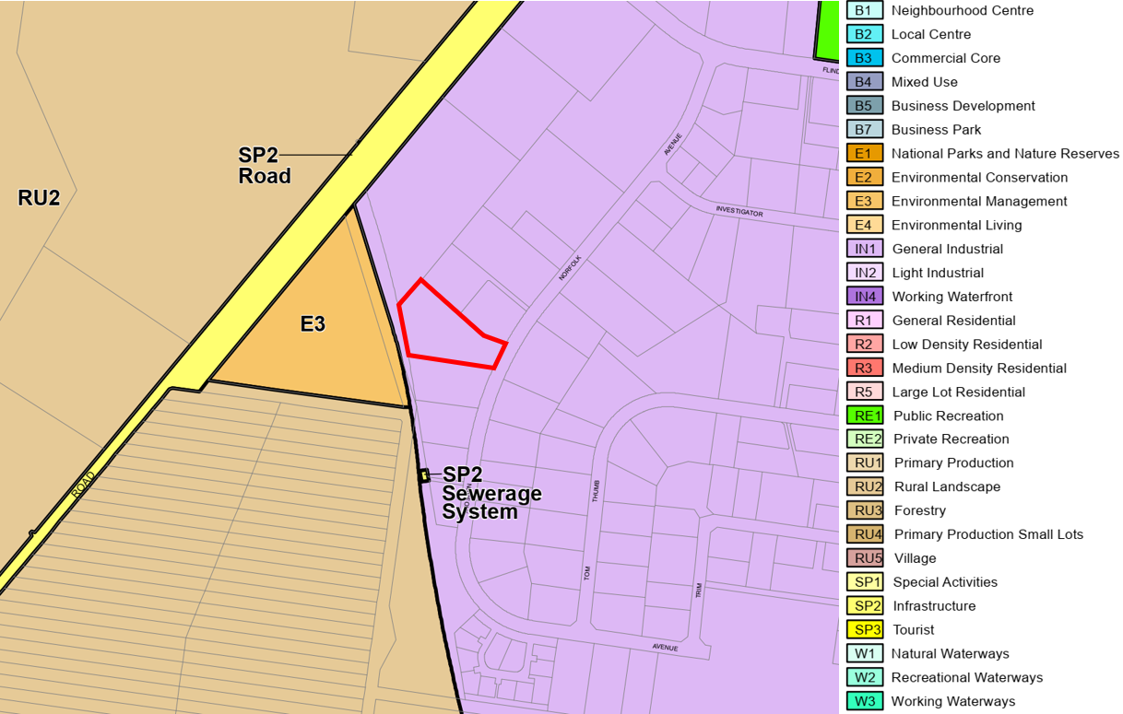

Figure 13 – Extract of SLEP 2014 land zoning map; the subject site is outlined by the red border)

**Characterisation and Permissibility**

The proposed development is referred to by the applicant’s Statement of Environmental Effects (SEE) as an ‘industrial development’ consisting of ‘industrial units’, however apart from the proposed ‘café’, the future land uses associated with the individual tenancies are not proposed as part of this DA.

The design of the development will provide each unit with storage areas, a loading bay and ancillary facilities such as car parking and mezzanine areas. The industrial units are therefore most appropriately defined by the SLEP 2014 as a ‘general industry’, the land use definition of which is as follows:

***general industry*** *means a building or place (other than a heavy industry or light industry) that is used to carry out an industrial activity.*

***Note—***

*General industries are a type of industry—see the definition of that term in this Dictionary.*

For reference, the SLEP 2014 definitions for ‘industry’ and ‘industrial activity’ are as follows:

***industry*** *means any of the following—*

1. *general industry,*
2. *heavy industry,*
3. *light industry,*

*but does not include—*

1. *rural industry, or*
2. *extractive industry, or*
3. *mining.*

***industrial activity*** *means the manufacturing, production, assembling, altering, formulating, repairing, renovating, ornamenting, finishing, cleaning, washing, dismantling, transforming, processing, recycling, adapting or servicing of, or the research and development of, any goods, substances, food, products or articles for commercial purposes, and includes any storage or transportation associated with any such activity.*

‘General industry’ is a form of development that is permissible with consent within the IN1 zone under the SLEP 2014.

A ‘café’ is type of ‘food and drink premises’, which is defined as follows:

***food and drink premises*** *means premises that are used for the preparation and retail sale of food or drink (or both) for immediate consumption on or off the premises, and includes any of the following—*

1. *a restaurant or cafe,*
2. *take away food and drink premises,*
3. *a pub,*
4. *a small bar.*

***Note—***

*Food and drink premises are a type of* ***retail premises****—see the definition of that term in this Dictionary.*

As per the note above, a ‘food and drink premises’ is a type of ‘retail premises’. ‘Retail premises’ are prohibited within the IN1 zone under the SLEP 2014.

While the SEE provides that the café is ancillary to the industrial component (and is therefore permissible), it is not demonstrated how the café is ancillary to the industrial use. The café will operate independently of the proposed industrial tenancies and is not proposed to exclusively serve the occupants of the industrial tenancies on the subject site. As such, the café is an independent component of the development and is therefore not an ancillary use.

A ‘take away food and drink premises’ is however singled out and identified as being permitted with consent within the IN1 zone, and for reference is defined as follows:

***take away******food and drink premises*** *means premises that are predominantly used for the preparation and retail sale of food or drink (or both) for immediate consumption away from the premises.*

***Note—***

*Take away food and drink premises are a type of food and drink premises—see the definition of that term in this Dictionary.*

To enable a food and drink offering on the site for the development, it is recommended the use and layout of the ‘café’ be modified so that it is in accordance with the SLEP 2014 ‘take away food and drink premises’ land use definition. To facilitate this, a consent condition has been recommended that will require deletion of the references to a ‘café’ from the plans, so that the premises provides a layout that enables it to be predominantly used for the preparation and retail sale of food or drink (or both) for immediate consumption away from the premises.

If undertaken in accordance with the recommended conditions, the proposal is permitted within the zone with the consent of Council.

**Zone objectives**

|  |  |
| --- | --- |
| **Objective** | **Comment** |
| * *To provide a wide range of industrial and warehouse land uses.* | The size, nature and layout of the proposed tenancies will enable provision of facilities that are capable of accommodating a variety of industrial and warehouse-type uses on the site. |
| * *To encourage employment opportunities.* | Aside from employment opportunities during construction, the tenancies will provide appropriate facilities for future employment-generating uses. |
| * *To minimise any adverse effect of industry on other land uses.* | The physical form of the proposed development will not adversely affect surrounding sites nor affect their ability to support industrial activities. While the specific operations of future businesses/industries on the site will be subject to separate consents, the size and design of the proposed tenancies are such that their future use is unlikely to adversely affect surrounding sites and/or land uses. The operation of the proposed take away food and drink premises will be contained within the subject site boundaries, and both its size and hours of operation will not adversely affect surrounding land uses. |
| * *To support and protect industrial land for industrial uses.* | The proposed development is to provide facilities to support individual small-to-medium industrial uses. The development more broadly will have no impact on the ability of surrounding sites and the locality to provide land for industrial-type uses. |
| * *To allow a diversity of activities that do not significantly conflict with the operation of existing or proposed development.* | The varying sizes of the proposed tenancies will enable the site to be occupied by a diverse range of small-scale industrial activities. While the future uses of those tenancies would be subject to separate assessments, the size of such occupations are likely to be such that they will not significantly conflict with existing operations on surrounding sites. |
| * *To enable other land uses that provide facilities or services to meet the day to day needs of workers in the area.* | The proposed development will not adversely affect the ability of surrounding sites to provide facilities or services that are capable of meeting the day-to-day needs of workers within the area. |

SLEP 2014 Clauses

|  |  |  |
| --- | --- | --- |
| **Clause** | **Comments** | **Complies/Consistent** |
| Part 2 Permitted or prohibited development | | |
| 2.7 Demolition requires development consent | The site is a vacant allotment. Demolition is not required. | N/A |
| Part 4 Principal development standards | | |
| 4.1 Minimum subdivision lot size | Subdivision is not proposed by this subject application. | N/A |
| 4.3 Height of buildings | (2A) If the [Height of Buildings Map](https://www.legislation.nsw.gov.au/view/html/inforce/current/epi-2014-0179/maps) does not show a maximum height for any land, the height of a building on the land is not to exceed 11 metres.  Maximum proposed building height: 7.82 metres | Yes |
| Part 5 Miscellaneous provisions | | |
| 5.10 Heritage Conservation | The subject site does not contain a heritage item, is not within a heritage conservation area and is not located in close proximity to a heritage item mapped under Schedule 5 of the SLEP 2014.  An AHIMS check has confirms that there are no items of indigenous heritage are located on/in close proximity to the site, noting that both the subject site and most surrounding sites have been subject to significant disturbance. In the event of approval, undiscovered finds can also be addressed via conditions of consent.  No further assessment is required. | N/A |
| Part 7 Additional local provision | | |
| 7.1 Acid Sulfate Soils | The site is mapped being affected by Class 5 Acid Sulphate Soils.  The site is not located within 500 metres of sites affected by Class 1, 2, 3 or 4 acid sulphate soils. Excavation works are not proposed to exceed 5 metres, and are unlikely to lower the water table.  No further assessment is required, and an acid sulphate soils management plan is not required to be prepared for the proposed works. | N/A |
| 7.2 Earthworks | Earthworks associated with the proposal are limited to excavation for floor/driveway slabs, footings and stormwater works. The depths of such excavation are not significant, and both the scale of the earthworks and the relatively level nature of the site is such that any potential impacts (e.g. sediment and erosion runoff) during works can be addressed through conditions of consent. | Yes |
| 7.5 Terrestrial biodiversity | The site is not mapped as being affected by terrestrial biodiversity, noting that the site has previously been cleared as part of the earlier subdivision of the site. | N/A |
| 7.6 Riparian land and watercourses | The site is not mapped as being affected by, nor being in close proximity to, areas mapped as riparian land and/or watercourses. | N/A |
| 7.9 HMAS Albatross airspace operations | The site is located approximately 3.5 kilometres northeast of HMAS Albatross. The height of the works is below the OLS surfaces for the airbase, and consent is not required from relevant Commonwealth bodies prior to determination. | N/A |
| 7.10 Development in HMAS Albatross Military Airfield buffer area | The subject site is mapped as being outside of the HMAS Albatross buffer area. | Yes |
| 7.11 Essential Services | The site is capable of being connected to all essential services required for the development. Adequate arrangements are capable for being made available when required. | Yes. |
| 7.21 Development on land in the vicinity of the Western Bypass Corridor | The site is mapped as not being within the vicinity of the Western Bypass Corridor. | N/A |
| 7.28 Development on land at South Nowra and Nowra Hill | The site is not listed as being affected by the provisions of the clause. | N/A |

## Draft Environmental Planning Instrument

There are no draft environmental planning instruments that are relevant to the proposal or the subject site.

## Any Development Control Plan

Shoalhaven DCP 2014

The following chapters of Shoalhaven Development Control Plan 2014 (SDCP 2014) apply to the assessment of the DA:

* G1: Site Analysis, Sustainable Design and Building Materials in Rural and Coastal Areas
* G2: Sustainable Stormwater Management and Erosion/Sediment Control
* G3: Landscaping Design Guidelines
* G7: Waste Minimisation and Management Controls
* G20: Industrial Development
* G21: Car Parking and Traffic
* G22: Advertising Signs and Structures
* G26: Acid Sulfate Soils and Geotechnical (Site Stability) Guidelines

A detailed assessment of relevant DCP conditions is appended to this planning assessment as **Attachment 2**. A summary of the assessment against relevant DCP chapters is provided within the table below.

|  |
| --- |
| Generic Chapters |
| **G1: Site Analysis, Sustainable Design and Building Materials in Rural and Coastal Areas** |
| A site analysis has not been provided with the DA. Despite lacking such information, details contained within other documents (e.g. survey plan, bushfire assessment report, aerial imagery, etc.) is such that there is sufficient information for an assessment to identify hazards and constraints, noting that there are no trees on the site, and the site is not constrained by other planning matters such as views and natural hazards other than bushfires. |
| **G2: Sustainable Stormwater Management and Erosion/Sediment Control** |
| The application is supported by stormwater drainage concept plans, which have generally been designed in accordance with Chapter G2. The site contains a slope to the rear of the site, therefore stormwater from the building roofs and other hardstand areas (i.e. parking, vehicle manoeuvring areas and pathways) is to be conveyed to OSD systems and discharged to the public drainage systems via two points at the northwest and southwest portions of the site.  Concern is raised by Council’s Development Engineer that the design of proposed internal drainage systems may pose a flooding risk to Units 16, 17, 21 and 22 in the event that the system is blocked during an event greater than the 10% AEP. Further, the design of the system beneath common walls may also not allow for simplified access to the pipe in the event of that maintenance and/or clearance of pipe blockages is required. Conditions have therefore been recommended by Council’s Development Engineer that will require modifications to the drainage system to ensure satisfaction within Section 5.1.1 of Part G2 of the DCP.  The drainage connection at the northwest part of the site is to an existing easement, which is satisfactory, subject to recommended conditions of consent. The plans however show that stormwater lines within the southwest part of the site encroach into part of an adjoining site (Lot 40 DP 802671) that is not covered by an easement to drain water; consent from the owner of that allotment has also not been provided. The creation and registration of a drainage easement on that adjoining site is therefore required before any consent for the proposed development becomes operational; a deferred commencement condition has therefore been recommended to in part address the requirements of Section 5.1.1 and 5.1.2 of Part G2 of the DCP.  Subject to the recommended conditions of consent from Council’s Development Engineer, the stormwater disposal arrangements are considered to be satisfactory. |
| **G3: Landscaping Design Guidelines** |
| There are no trees on the site, therefore provisions relating retention and/or removal of existing trees do not apply.  The submitted landscape plan (refer to ***Figure 3***) is generally consistent with DCP requirements, however the layout of the landscape plan within the rear of the site is inconsistent with the architectural plans (refer to ***Figure 2***), with the latter showing less space for the establishment and growth of trees. A condition is therefore recommended that will require construction plans to reflect the landscape layout of the landscape plans that are recommended for approval.  Street trees are not proposed, however this is acceptable in the circumstances of the proposal, given the presence of elevated 11kV electricity lines within the road reserve to the front of the site. |
| **G7: Waste Minimisation and Management Controls** |
| Each proposed industrial unit is to provide for an internal waste storage area. While amendments to the plans have provided for an additional communal waste collection point (for a total of two such facilities), the travel distances to these facilities exceed the 75 metres specified by the *Better Practice Guidelines for Waste Management and Recycling in Commercial and Industrial Facilities*, which is referenced by Control A.1.1.  As a result, conditions are recommended that will require the following to enable compliance with Part G7 of the DCP   * Construction plans will be required to provide for the creation of an additional waste collection point to Unit 19 (this is attainable through the removal of three car parking spaces, noting that the site proposes parking that is well in excess of minimum DCP requirements under Part G21 of the DCP), and * The provision of an amended Waste Minimisation and Management Plan (WMMP) that is prepared in accordance with Chapter G7 of the SDCP 2014. The WMMP must be approved by Council or an accredited certifier before the issue of a Construction Certificate.   Provided that the above is addressed, the requirements of Part G7 of the DCP will be satisfied. |
| **G20: Industrial Development** |
| |  |  |  | | --- | --- | --- | | **5.1 Site Suitability** | | | | **Performance Criteria**  P1 The development is compatible with the character of the site  P2 The site has sufficient area and dimensions to accommodate all areas necessary for the proposed industrial development.  P3 Adjoining sites are not be negatively impacted by the proposed development and drainage works  Comment: the development is generally consistent with the above Performance Criteria. A non-compliance arises with regard to the lack of a site analysis plan, as required by Section A1.2. | | | | **Acceptable Solutions** | **Proposal** | **Compliance** | | A1.2 A site plan and site analysis plan is submitted with the development application. | A site analysis plan has not been submitted. Despite the lack of such information, the other information provided to Council (i.e. a survey plan, site plan, etc.) is otherwise sufficient for an assessment to identify hazards and constraints, noting that there are no trees on the site, and the site is not constrained by considerations such as views and natural hazards other than bushfires. The lack of a site analysis plan is therefore considered to be acceptable in this instance. | No | | **5.2 Building Setbacks** | | | | **Performance Criteria**  P4 The building setbacks are  consistent with adjoining development and enable:  • the efficient use of the site;  • vehicle manoeuvring areas where vehicles can enter and exit the site in a forward direction;  • visible staff and visitor parking;  • an attractive streetscape character;  • the location of utility services, storage and drainage paths; and  • Unimpeded development of adjacent sites.  **Additional Area Specific Controls**  **Performance Criteria**  P5 The building setbacks are satisfactory to Council in the Flinders Industrial Estate, South Nowra.  Comment: The development is generally consistent with the above Performance Criteria, however a front setback variation is caused by the cantilevered roof above the front of the café (the front setbacks to the front building lines of the northern and southern-most buildings comply with the minimum 15 metre requirement specified by A5.2). | | | | **Acceptable Solutions** | **Proposal** | **Compliance** | | A5.2 For all other sites, a minimum front setback of 15m and minimum secondary setback of 10m is provided. | Proposed setbacks:   * To café roof: 12.98m * To building line: 15m   Secondary setback controls do not apply, as the site has only one road frontage. | No | | Non-compliance  **Acceptable Solution proposed to be varied**  A5.2 Minimum front setback of 15 metres.  **Extent of variation**  2.02 metres (or 13.5%) variation caused by the cantilevered roof above the front of the café (the front setbacks to the front building lines of the northern and southern-most buildings comply with the minimum 15 metre requirement specified by A5.2).  **Applicant’s justification for variation**  None provided (the submitted SEE refers to the building line setback only).  **Council Consideration of the request to vary the acceptable solution**  The element which breaches the 15-metre setback control is an open/lightweight element, as it is an open structure that is to be finished in contrasting colours and in a location that is well below the roof parapet at the front of the building. A large landscaped area is proposed within the front setback (and which will be further increased in size a result of the condition requiring deletion of the outdoor dining area) that will also include two large trees, which will further screen the café roof and filter its visual impact from the public domain.  The element breaching the minimum 15 metre setback will subsequently not add to the height, bulk and scale of the development, and will not adversely affect the character of the streetscape.  The variation is therefore satisfactory and supportable on merit in this instance.  The proposal is therefore unlikely to set an undesirable precedent granted the specific nature of the variation and reasoning for the variation which are particular to the development. | | |  |  |  |  | | --- | --- | --- | | **5.3 Building and Site Design** | | | | **Performance Criteria**  P11 The design incorporates the use of materials appropriate to the emerging character of the locality, with innovation being encouraged.  Comment: The development is generally consistent with the above Performance Criteria, however a non-compliance is caused by large and unbroken expanses of walls that are proposed along the side elevations addressing the northern and southern boundaries. | | | | **Acceptable Solutions** | **Proposal** | **Compliance** | | A11.3 Building design does not include large unbroken expanses of wall or building mass. | The DA proposes a variation, in that large unbroken expanses of walls are proposed along the side elevations addressing the northern and southern boundaries. | No | | Non-compliance  **Extent of variation**  A numerical control is not provided.  **Applicant’s justification for variation**  *The proposal includes unbroken expanses of wall to the side boundaries. This practice is commonplace in the industrial estate. The design has been articulated to the public domain, being the front elevation, and articulated internally where visitors will venture. The building’s articulation and schedule of materials provides interest whilst reflecting the industrial character of the area. Therefore, Performance Criteria P11 is satisfied. The proposal will foster economic growth through its development, and provides a well-designed, quality industrial development as designed by CK Architecture. There is no adverse impact to the amenity or privacy of adjoining industrial premises, and the application has been supported by a bushfire report to respond to natural hazards. The design provides adequate vehicular access and on-site manoeuvring.*  **Council Consideration of the request to vary the acceptable solution**  The visual impact of the development will be reduced to the north, as a result of existing development at 15 Norfolk Avenue that is already built with a zero-side setback to the common boundary. While the location of development on the adjoining site to the south (i.e. 19 Norfolk Avenue) will allow for the variation to be visible from the Norfolk Avenue road reserve, the development controls for the locality likely envision the setbacks of future development to be more akin to that proposed by the subject DA.  It is agreed with the SEE’s arguments that there are numerous other examples within the Flinders Industrial Estate where industrial developments have been permitted with large unbroken expanses on/close to side boundaries; a review of the area noted examples including:   * 11 Norfolk Avenue * 35 Norfolk Avenue * 10 Tom Thumb Avenue * 28 Trim Street   It is also agreed that the variation will not adversely affect the amenity of surrounding sites (noting that such sites either contain other industrial developments or will remain undeveloped for the foreseeable future), nor will the variation adversely affect defence against bushfires.  While issues are noted with regard to onsite manoeuvring by articulated vehicles, this issue is unrelated to the subject variation proposed by this DA.  The proposal is unlikely to set an undesirable precedent for the reasoning outlined above. The proposed variation is therefore considered to be satisfactory and supportable on merit in this instance. | | | | **Performance Criteria**  P13 The building design is energy efficient and provides good solar access to the development and surrounding development.  Comment: The development is consistent with the above Performance Criteria.   |  |  |  | | --- | --- | --- | | **Acceptable Solutions** | **Proposal** | **Compliance** | | A13.2 A reliable and accurate shadow diagram may be required to demonstrate the impact of shadows resulting from existing and proposed building works between 9am and 3pm on June 21. | Solar access plans showing overshadowing impacts for 22 September rather than for June. Despite such a deficiency, the layout of development on the adjoining industrial site to the south and the proximity of the subject site to the nearest residential development is such that the proposal will not adversely affect the amenity of areas sensitive to overshadowing. | No | | | | |
| **G21: Car Parking and Traffic** |
| **5.1 Car Parking Schedule**  The proposed development includes a mix of uses which are to be considered for the purposes of parking as follows:   1. Industry One (1) space per 100m2 of GFA 2. Cafe One (1) space per 100m2 of GFA   Required car parking based on the above rates is as follows:   1. Industry  * Excluding mezzanines: 54.7 (rounded up to 58) * Including mezzanines: 63.4 (rounded up to 64)  1. Café 5.7 spaces (rounded up to 6) 2. Total  * Excluding mezzanines: 64 * Including mezzanines: 70   A total of 115 car parking spaces are provided on-site (including two (2) accessible spaces).  A recommended condition of consent will require that at least six (6) car parking spaces be made available at all times for café (take away food and drink premises) customers.  As discussed within the assessment of DCP Part G7, a recommended consent condition will require that an additional communal waste collection area be provided to reduce travel distances between units and collection points. As the proposed site layout provides limited landscaped areas and proposed parking rates that will significantly exceed minimum requirements, a condition is recommended that will require three (3) parking spaces to be converted to a communal waste storage area. A condition is therefore recommended that will require that at least 112 onsite car parking spaces be provided (as opposed to the 115 currently proposed).  **6.1 Traffic**  Comment: The DA has been assessed by Council’s Development Engineer and Traffic Unit. No objections are raised to the layout and design of car parking spaces, subject to recommended conditions.  **6.2 Access**  Access to the site is proposed to be provided from Norfolk Avenue for all vehicles via a two-way driveway that is to be separated by a central island median.  Comment: While no issue is raised with the design of facilities for vehicular entry and egress, the proposed development does not demonstrate satisfactory provisions for pedestrian safety in accordance with Acceptable Solution A10.11. While the site provides for continuous and line-marked paths of travel between the front of the site and Units 1-15 and 36-37, line-marked pathways do not connect these pathways to buildings that will contain Units 18-22 and 23-30.  A condition is therefore recommended that will require amendments to be made to ensure that adequately-marked and connected pedestrian pathways are provided through the site in accordance with relevant standards; the condition will require such pathways not be permitted to encroach upon proposed landscaped areas, in order to both maximise landscaped area and visibility of pedestrian routes throughout the site.  **6.3 Manoeuvrability**  Comment: The submitted information does not satisfy the requirements of Acceptable Solutions A12.1 and A12.2. The swept path plans provided with the most recent amendments to the plans indicate that the DA seeks consent for access for vehicles up to and including 19-metre-long articulated vehicles (i.e. semi-trailers).  The submitted swept path plans are inadequate, as they indicate that:   * Access from the south is only attainable by using the south-bound lane of Norfolk Avenue (i.e. access from the south requires using the wrong side of the road). * Egress to the north is only attainable by using the south-bound lane of Norfolk Avenue (i.e. egress to the north requires using the wrong side of the road), and also requires encroachment upon the centre dividing island. * Manoeuvring space around Unit 23 requires encroachment upon landscape areas (noting that the landscape plans propose wider landscaped areas within this location). * Manoeuvring space around Unit 24 requires encroachment upon landscape areas. * It has not been demonstrated that articulated vehicle access and associated manoeuvring to Units 10-15 and 16-19 is possible without reversing a significant distance within the site. * The proposed loading areas within the industrial units are of insufficient lengths to accommodate a 19-metre-long vehicle without significant encroachment into the ’avenues’ throughout the site, and no shared loading facilities for a 19-metre-long vehicle are proposed.   Swept path plans for Heavy Rigid Vehicles (HRVs) also show an impractical approach angle to the site in addition to encroachment upon landscaped areas in order to manoeuvre around Unit 23.  No justification has been provided with regard to the above.  In addition to recommended conditions of consent by Council’s Development Engineer, the following consent conditions are recommended that will require the following:   * Prohibition of articulated vehicles from the site, with signage to be erected at the entrance to the site to advise incoming traffic of this restriction. * Revised swept path plans for HRVs are to be submitted for Council’s approval prior to the issue of a Construction Certificate.   **6.4 Service Areas**  Comment: Proposed internal loading facilities within each unit are likely adequate for future proposed uses. Refer however to Section 6.3 (above) for comments regarding issues about onsite manoeuvrability by larger vehicles (i.e. semi-articulated trucks and HRVs). |
| **G22: Advertising Signs and Structures** |
| |  |  |  | | --- | --- | --- | | **5.5 General Controls** | | | | **All Business and Industrial Zones**  **Performance Criteria**  P1 To ensure advertising signs/structures:   * are associated with a lawful use of the land; and * relates to the land, or to the premises situated on that land; or * identifies a person residing or carrying on an occupation or business on the land or premises; and/or * gives particulars of the goods or services dealt with or provided on the land or premises; * is a directional sign for an approved tourist facility in the Shoalhaven; or * Is an advertisement for a business located in the Shoalhaven. * relate well to and integrates with existing built and vegetated forms * do not dominate the streetscape or skyline * do not adversely affect traffic safety * do not restrict sight distances at entrance/exit to any property * do not obstruct sightlines to signs on adjoining property * do not detract from the heritage significance of the building or place * do not project over windows or architectural features of a building * are consistent with the design guidelines outlined in this Chapter are treated on the rear view of single-sided signs to blend with the surrounding streetscape or field of view * reduce visual clutter * achieve equity between property owners/occupiers * have a design relationship between multiple signs * have a design relationship to each other individual signs in the case of a free-standing directory sign * are capable of accommodating the signs of other tenants in respect of any free-standing sign on a multi-tenanted site * Affixed to structures are wholly contained within the dimensions of the structure. | | | | **Acceptable Solutions** | **Proposal** | **Compliance** | | *Free-Standing Signs*  A1.4 Maximum sign face area should not exceed 0.35m2 of sign face area per linear metre of road frontage. | Frontage length: 40.435m2  Maximum permitted sign area: 14.15m2  Proposed sign area: 16.38m2 (per side) | No | | A1.5 Maximum sign face area of any one (1) sign is not to exceed 8m2. e.g. A 20m frontage will permit 7m2 of sign face area for a freestanding sign. | Maximum permitted sign area: 8m2  Proposed sign area: 16.38m2 (per side) | No | | Non-compliance  **Acceptable Solution proposed to be varied**  A1.4 Maximum sign face area should not exceed 0.35m2 of sign face area per linear metre of road frontage.  A1.5 Maximum sign face area of any one (1) sign is not to exceed 8m2.  **Extent of variation**  A1.4 - 2.23m2 (or 15.8%)  A1.5 - 8.38m2 (or 104.8%)  **Applicant’s justification for variation**  None provided (the calculations within the SEE suggest that the area calculations are based upon each individual signage space on the free-standing sign, rather than the total area).  **Council Consideration of the request to vary the acceptable solution**  The variation to the signage area is likely a consequence of the large number of proposed units (and the subsequent need to provide sufficient space on the free-standing sign to provide business identification signs for all proposed businesses), and the design of the free-standing sign will promote suitable rationalisation of signage in areas immediately visible from the public domain. Given the size of the site, site frontage and proposed development, the size of the proposed signage variation is not significant, therefore any variation to the permitted signage area will not be discernible when viewed from the public domain.  Having regard to the particular circumstances of the site, the proposal is unlikely to set an undesirable precedent. The proposed variation is therefore considered to be satisfactory and supportable on merit in this instance. | | | |

## iiia) Any planning agreement that has been entered into under section 7.4, or any draft planning agreement that a developer has offered to enter into under section 7.4

None relevant.

## Environmental Planning and Assessment Regulation 2000

**Note:** Pursuant to cl. 3 of Schedule 6 of the *Environmental Planning and Assessment Regulation 2021*, the *Environmental Planning and Assessment Regulation 2000* applies to the subject application as it was lodged but not determined before 1 March 2022.

|  |  |
| --- | --- |
| **Clause 4 - What is designated development?** | The proposed development does not constitute a form of designated development. |
| **Clause 5 - Advertised development** | The development was advertised for a period of 30 days in accordance with the Council Community Consultation Policy. One (1) submission was received during this period. |
| **Division 3 Development applications for integrated development** | The DA is not a form of integrated development under Section 4.46 of the EP&A Act. |
| **Clause 92 Additional matters that consent authority must consider** | Not applicable. As a vacant site, demolition works are not proposed, the site is not subject to Schedule 7 of the Act, the site is not within an LGA subject to the *Dark sky Planning Guideline* and the site is not located within the Penrith LGA. |
| **Clause 93 Fire safety and other considerations** | Not applicable, as a change of use is not proposed. |
| **Clause 94 Consent authority may require buildings to be upgraded** | Not applicable, as the proposal does not propose the upgrade of an existing building. |
| **Division 8A Prescribed conditions of development consent** | Prescribed conditions are to be imposed as required. |

## Repealed

Shoalhaven Contribution Plan 2019

The development is subject to the payment of s7.11 Development Contributions under Section 2.4 of the Shoalhaven Contribution Plan 2019 (Plan). Section 2.4 of the Plan is extracted below:

***Commercial & industrial development***

*When commercial or industrial subdivision is proposed, contributions will be levied at a rate of 1 ET per lot created.*

*Additional contributions may be levied upon finalisation of a development application for a specific use of a lot (i.e. building, warehouse, storage facility, etc.) which is greater development than the original 1 ET credited to the lot. These contributions are levied as per the rate detailed in Section 3.7 of this Plan.*

For reference, industrial developments are levied at a rate of one Equivalent Tenement (ET) per 200m2 of land to be developed (including car parks and landscaped areas).

A condition is recommended that will govern the S7.11 contributions to be paid.

Policy for the Assessment of Council’s Own Development Applications Policy Number: POL16/226

The application relates to Council owned/managed land.

Council is the applicant.

The application is a major DA which is to be determined by the Southern Regional Planning Panel as required by SEPP (State and Regional Development) 2011.

External assessment of the application is not required under the policy. The assessing officer was not involved in the preparation or lodgement of the application with Council and determination of the application is to be via the Southern Regional Planning Panel.

The assessment is consistent with the Policy.

Nowra Bomaderry Structure Plan 2008

The proposed development is unlikely to impact the Nowra Bomaderry Structure Plan.

|  |
| --- |
| (b) The Likely impacts of that development, including environmental impacts on the natural and built environments, and social and economic impacts in the locality |

| **Head of Consideration** | **Comment** |
| --- | --- |
| Natural Environment | The application will involve minimal disturbance to the natural environment. The site is not within an area of biodiversity significance, and tree removal is not proposed. New tree planting and landscaping is proposed within the site including the setback to Norfolk Avenue. The additional landscaping will have a positive impact on the natural environment. Potential environmental impacts during works and general environmental impacts (e.g. noise associated with plant equipment) will be mitigated via recommended conditions in the event of approval. Potential adverse impacts on the natural environmental and local amenity (e.g. noise) that are associated with the future occupation and use of industrial units will be separately addressed by future consents. |
| Built Environment | Impacts on the built environment are addressed within the detailed assessment of the SDCP 2014. The proposed development is however generally reflective of the built form and scale of industrial development in the locality, particularly newer industrial unit and warehouse-type developments to the east and southeast of the site within the Flinders Industrial Estate. |
| Social Impacts | The development will not give rise to adverse social impacts. |
| Economic Impacts | It is considered that there will be no adverse economic impacts. The proposal facilitates further industrial development that will provide adequate facilities for associated uses. The proposal will have positive economic impacts with regard to construction and economic development through new employment opportunities. |

|  |
| --- |
| (c) Suitability of the site for the development |

The development is consistent with the applicable environmental planning instruments. The development is consistent with the objectives of the IN1 General Industrial zone and relevant clauses under SLEP 2014.

The development is generally consistent with the relevant chapters of SDCP 2014 and relevant Council Policy, and risks associated with the bushfire hazard affecting the site can be appropriately mitigated.

Subject to the recommended conditions of consent, the site will be suitable for the development.

|  |
| --- |
| (d) Submissions made in accordance with the Act or the regulations |

The DA was notified in accordance with Council’s Community Participation Plan for a 30-day period that commenced on 8 December 2021 until 7 January 2022.

One (1) submission was received by Council. The submission does not specify whether it objected to the proposed development, however the matter for consideration that was raised is outlined below:

|  |  |
| --- | --- |
| **Summary of Public Submissions** | |
| **Objection Raised** | **Comment** |
| The submission “…*requests that Council carefully consider the intensification of the industrial area, particularly in relation to impacts of increased traffic, the interaction of light and heavy vehicles, and vehicle safety entering/exiting driveways in the vicinity of a busy concrete plant*.*”* | Impacts of parking, traffic generation and both vehicular access and internal circulation are matters that have been considered by this planning assessment (refer to the assessment of the SDCP 2014 for details). It has been found that, subject to the recommended conditions of consent, the proposed development:   * Will provide for adequate parking, * Will not result in excessive traffic generation within the surrounding road network, and * Will allow for adequate vehicular access and egress in a manner that will not adversely affect surrounding sites. |

# (e) The Public Interest

The proposed development complies with the provisions of the SLEP 2014, is consistent with the objectives of the IN1 zone and is generally consistent with the SDCP 2014. Subject to conditions of consent, the development is not expected to have any unacceptable negative impacts on the environment, or the amenity of the locality as detailed in this report that would warrant refusal of the DA.

# Recommendation

This application has been assessed having regard for Section 4.15 (Matters for consideration) of the Act.

This application has been subjected to detailed analysis of the main issues identified in this report. These issues have been resolved during the assessment of the DA, submission of amended documentation by the applicant and recommended conditions of consent.

Council is satisfied that the current proposal meets the provisions of relevant environmental planning instruments and is consistent with the relevant provisions and objectives within the SLEP 2014 and the SDCP 2014. Any potential impacts have been adequately addressed via recommended conditions of consent.

The application is considered capable of support as there are no substantive planning reasons to warrant refusal. The DA however relies upon the creation of easements on the allotment to the rear of the site both for bushfire defence and stormwater drainage purposes. Deferred commencement conditions are therefore recommended to ensure that the creation and registration of such easements occurs prior to the commencement of any consent issued by the SRPP.

As such, it is recommended that Development Application No. DA21/1001 be approved via deferred commencement, subject to conditions of consent as recommended at **Attachment 1**.